

**Tribhuvan University**

**Faculties of Humanities and Social Sciences**

**KHWOPA ECOMMERCE**

**A PROJECT REPORT**

**Submitted to**

**Department of Computer Application**

**Danfe College**

**Sinamangal, Kathmandu**

***In partial fulfillment of the requirements for the Bachelors in Computer Application***

**Submitted by**

Suman Mushyakhwo (6-2-920-32-2020)

September, 2024

**Under the Supervision of**

**Deepak Thakur**



**Tribhuvan University**

**Faculty of Humanities and Social Sciences**

**Danfe College**

**SUPERVISOR’S RECOMMENDATION**

There by recommend that this project prepared under my supervision by **Suman Mushyakhwo** entitled “**KHWOPA ECOMMERCE**” in partial fulfillment of the requirements for the degree of Bachelor of Computer Application is recommended for the final evaluation.

**-------------------------**

**SIGNATURE**

Mr. Deepak Thakur

**PROJECT SUPERVISOR**

BCA Department

Danfe College, Sinamangal, Kathmandu



**Tribhuvan University**

**Faculty of Humanities and Social Sciences**

**Danfe College**

**LETTER OF APPROVAL**

This is to certify that this project prepared by **Suman Mushyakhwo** entitled “**KHWOPA ECOMMERCE**” in partial fulfillment of the requirements for the degree of Bachelor in Computer Application has been evaluated. In our opinion it is satisfactory in the scope and quality as a project for the required degree.

|  |  |
| --- | --- |
| ………………………………  **Mr. Deepak** **Thakur**  Supervisor  BCA Department  Danfe College, Sinamangal  Kathmandu | ……………………………..  **Mr. Tul Bahadur Rai**  Program Coordinator  BCA Department  Danfe College, Sinamangal  Kathmandu |
| **…………………………………..**  **Internal Examiner** | **…………………………………**  **External Examiner** |

# ABSTRACT

The Khwopa Ecommerce is web-based application. This system provides customers to enhance the online shopping experience. The system has two types of users: Admin and Customer. This system uses CRUD operations to manage Khwopa Ecommerce System. Admin is responsible to upload data about products and Category in to the system. Customers can sign up in to the system, and view Products and order that products. Customers are allowed to review products after buying products. This Khwopa Ecommerce System is designed to be user-friendly and easy to use.

***Keywords: Khwopa Ecommerce, Product Management, Category Management***

# ACKNOWLEDGEMENT

Apart from the efforts, I would like to thank **Deepak Thakur**, our project coordinator and lecturer, for his patience, support and open-mindedness. Without his encouragement and guidance this project would not have materialized. We feel motivated and encouraged every time we attend his meeting. We take this opportunity to express our gratitude to the people who have been instrumental in the successful Completion of this project. The guidance and support received from all the members who contributed and who are contributing to this project, was vital for the success of the project.

# TABLE OF CONTENTS

ABSTRACT i

ACKNOWLEDGEMENT ii

TABLE OF CONTENTS iii

LIST OF TABLES iv

LIST OF FIGURES v

LIST OF ABBREVIATIONS vi

CHAPTER 1: INTRODUCTION 1

1.1. Introduction 1

1.2. Problem statement 2

1.3. Objective 2

1.4. Scope and Limitation 2

1.5. Development Mythology 3

1.6. Report Organizations 3

CHAPTER 2: BACKGROUND STUDY AND LITERATURE REVIEW 4

2.1. Background Study 4

2.2. Literature Review 5

CHAPTER 3: SYSTEM ANALYSIS AND DESIGN 7

3.1. System Analysis 7

3.2. System Design 13

3.3. Algorithm Used 17

CHAPTER 4: IMPLEMENTATION AND TESTING 19

4.1. Implementation 19

4.2. Testing 23

CHAPTER 5: CONCLUSION AND FUTURE RECOMMENDATIONS 28

5.1. Lesson Learnt 28

5.2. Conclusion 28

5.3. Future Recommendations 28

REFERENCES 29

Bibliography 29

APPENDICES 30

# LIST OF TABLES

**Table 1: Test Case 1 Sign Up** 23

**Table 2: Test Case 2 Sing Up Unsuccessful** 24

**Table 3: Test Case 3 Login** 25

**Table 4: Test Case 4 Add Products** 26

**Table 5: Test Case 5 System Test** 27

LIST OF FIGURES

**Figure 3.1Use Case Diagram** 8

**Figure 3.2 Gantt chart** 9

**Figure 3.3 Entity-Relationship Diagram** 10

**Figure 3.4 Context level Diagram of Khwopa Ecommerce** 11

**Figure 3.5 DFD level 1 of Khwopa Ecommerce** 12

**Figure 3.6 Architectural Design of Khwopa Ecommerce** 13

**Figure 3. 7 Database schema of Khwopa Ecommerce** 14

**Figure 3.8 :Login Page UI of Khwopa Ecommerce** 15

**Figure 3.9 Signup page UI of Khwopa Ecommerce** 15

**Figure 3.10 Physical DFD** 16

LIST OF ABBREVIATIONS

**CSS** Cascade Style Sheet

**DFD** Data Flow Diagram

**ER** Entity Relationship

**FR** Functional Requirement

**GSMS** Gym Subscription Management System

**HTM**L Hypertext Markup Language

**MYSQL** My Structured Query Language

**PHP** Hypertext Preprocessor.

**UC** Use Case

**UI** User Interface

# 

# CHAPTER 1: INTRODUCTION

## Introduction

Khwopa E-Commerce is a dynamic digital marketplace designed to elevate the online shopping experience by offering a broad selection of products and services tailored to consumer needs. The platform stands out with its user-friendly interface and personalized shopping features, providing customers with a smooth and engaging experience. Leveraging advanced e-commerce technologies, Khwopa E-Commerce integrates comprehensive inventory management, streamlined product management, and efficient order processing. This platform not only modernizes the shopping experience but also supports small and medium-sized businesses by connecting them with a larger online audience. By blending robust e-commerce functionality with a focus on user satisfaction, Khwopa E-Commerce aims to be a one-stop solution for online shoppers, fostering growth and innovation in the digital marketplace.

A key strength of Khwopa E-Commerce lies in its use of cutting-edge e-commerce technologies. Through advanced inventory management systems, the platform is able to maintain real-time stock levels, reducing the chances of stock outs and enabling smooth, efficient restocking processes. Product management features allow sellers to update and showcase their products with rich descriptions, images, and categories, ensuring that consumers can easily find exactly what they're looking for. The platform’s order processing capabilities streamline the entire purchasing experience from cart to checkout, with fast, reliable processing that reduces wait times and improves customer satisfaction.

At its core, Khwopa E-Commerce is committed to fostering a strong sense of user satisfaction. By combining powerful e-commerce functionality with a focus on seamless, enjoyable shopping, the platform aspires to be a one-stop solution for online shoppers. It fosters growth and innovation within the digital retail landscape, making online shopping not only convenient but also impactful for both consumers and businesses alike. With this blend of technology, accessibility, and user focus, Khwopa E-Commerce is well-positioned to become a key player in the rapidly evolving world of digital marketplaces.

## Problem statement

The rapid growth of e-commerce has revolutionized retail, enabling businesses to reach customers beyond geographical limitations and offering consumers unprecedented convenience. However, small and medium-sized businesses, especially in developing regions, face significant challenges in adopting e-commerce. These challenges include limited access to digital infrastructure, insufficient technical expertise, and financial constraints that inhibit the ability to create and maintain an online presence. Additionally, issues related to consumer trust, payment security, and logistical barriers further complicate the adoption of e-commerce solutions. As a result, many businesses struggle to compete in an increasingly digital economy, limiting their growth potential and reducing their ability to serve a wider customer base. There is a critical need for accessible, cost-effective, and user-friendly e-commerce platforms that can empower these businesses to overcome these challenges, ensuring that they can thrive in the digital marketplace.

## Objective

* To offer customers easy access to products through an intuitive online platform.
* **To** enable to reach wider markets and increase their sales potential.

## Scope and Limitation

* + 1. **Scope of system**
* It includes essential e-commerce functionalities such as user registration, product management, and order management.
* Features a user-friendly interface designed for both admins and customers.
* Deliveries a complete digital shopping solution, enabling streamlined management of products, orders and customer interactions.
  + 1. **Limitations of existing system**
* Operates solely as a web-based application, limiting accessibility for users who prefer mobile platforms.
* Only Cash on Delivery no payment integrations

## Development Mythology

The Khwopa E-commerce platform was developed using the Spiral Model, a software development process that combines iterative development with systematic aspects of the waterfall model. The Spiral Model is ideal for complex projects that require frequent refinement and continuous risk assessment, making it suitable for this e-commerce platform due to its evolving requirements and the need for flexibility.

## Report Organizations

**Chapter 1: Introduction** - Introduction to the Khwopa E-commerce system, including the problem statement, objectives, scope, and limitations.

**Chapter 2: Background Study and Literature Review** - Background study and literature review of the Khwopa E-commerce system and related platforms.

**Chapter 3: System Analysis and Design** - Functional and non-functional requirements, feasibility analysis, and architectural design of the system.

**Chapter 4: Implementation and Testing** - Tools, technologies, and testing methodologies used in the system's development.

**Chapter 5: Conclusion and Future Recommendations** - Project outcomes, lessons learned, and future recommendations for the platform.

# CHAPTER 2: BACKGROUND STUDY AND LITERATURE REVIEW

## 2.1. Background Study

The rise of e-commerce has transformed traditional shopping by enabling consumers to browse and purchase goods from anywhere at any time, fostering a global marketplace accessible to anyone with internet access. Digital retail has empowered businesses to reach wider audiences, scale their operations, and offer diverse product assortments, making shopping convenient and efficient for consumers. Large-scale platforms like Amazon, Alibaba, and eBay have popularized e-commerce worldwide by leveraging digital infrastructure, data analytics, and secure payment gateways, creating seamless online shopping experiences. Consequently, e-commerce has become a key driver of economic growth, influencing consumer behavior and redefining traditional retail.

In developing regions like Nepal, however, the transition to e-commerce presents unique challenges. Many businesses lack the digital infrastructure, financial resources, and technical expertise to engage effectively in the online marketplace. For instance, internet penetration is increasing, but rural areas still experience limited access, affecting business participation in e-commerce. Additionally, consumer trust in online payments and logistical challenges further hinder e-commerce growth, as does the prevalent reliance on cash transactions. Despite these hurdles, there is significant potential for growth, with local e-commerce platforms emerging to address these challenges and support small businesses in adopting digital sales models.

Khwopa E-Commerce was conceived to serve as an accessible, scalable digital marketplace for local businesses in Nepal, helping them expand their reach within the growing online consumer market. By offering core e-commerce functionalities such as product listings, and order management, Khwopa E-Commerce aims to simplify the process of entering the online marketplace for small and medium-sized businesses. Through this initiative, the platform seeks to democratize e-commerce access for businesses, enabling them to compete and thrive in a digital economy.

## 2.2. Literature Review

1. **Study of Existing System**

In order to design a system, it was essential to study existing e-commerce platforms and identify their strengths and limitations. Major global e-commerce platforms like Amazon, eBay, and Alibaba have transformed how people shop by offering vast product ranges, competitive pricing, and convenient shopping experiences. However, these platforms are designed for global scalability and often overlook the unique needs of small, specific markets.

In Nepal, e-commerce is an emerging sector, gradually gaining traction as internet access and smartphone usage increase. Leading platforms like Daraz, SastoDeal, and HamroBazar cater to local demands, with Daraz being particularly influential due to its connection with Alibaba. Nepal’s unique challenges, such as difficult terrain and limited road infrastructure, make logistics complex and costly, especially outside urban areas. Payment options are expanding, with digital wallets like eSewa and Khalti gaining popularity, though cash on delivery remains dominant due to consumer trust issues with online payments and product quality concerns.

As Nepal’s digital economy grows, the e-commerce sector presents vast opportunities. Government support in improving logistics infrastructure and introducing more streamlined e-commerce regulations could accelerate growth. Expanding rural connectivity, building consumer trust, and diversifying payment options will be key to reaching a broader population. With these changes, e-commerce in Nepal could become a powerful economic driver, mirroring the global trend and paving the way for new business models tailored to the country’s specific challenges and opportunities.

1. **Literature review**

The field of e-commerce has grown exponentially over the last two decades, with a significant body of research examining its impacts on both businesses and consumers. Numerous studies have highlighted the benefits of e-commerce in terms of market expansion, operational efficiency, and customer satisfaction. However, research also indicates that small businesses, particularly those in developing regions, face several challenges when adopting e-commerce. These challenges include high initial costs, limited access to technology, and a lack of digital literacy.

Choosing an electronic trading platform is difficult if you want that your online shop to evolve, to have a large number of customers and orders, requiring automating many tasks and freeing up your time to focus on other aspects of the business. The online store developed by a software company specializing offering a flexible platform support is the best way to optimize business process online [1]. Consequently, companies have integrated the electronic market in their strategies to increase visibility and access the global market, leading to the growth of electronic commerce (E-commerce) [2]. E-commerce refers to the sale and purchase of goods and services through the internet, with the transfer of money and data to complete the transactions [3]. E-commerce platforms facilitate product information discovery that enables comparisons and decision-making [4]. They aim to replicate consumer in-store experiences and interactions to influence purchasing decisions [5].

# CHAPTER 3: SYSTEM ANALYSIS AND DESIGN

## 3.1. System Analysis

The system analysis of the system is done by conducting requirement analysis, feasibility analysis, data modeling, and process modeling as follows:

**3.1.1. Requirement Analysis**

1. **Functional Requirements:**

A Functional Requirements is an outline of the services that the KHWOPA ECOMMERCE must offer. Feature the system must provide are refined into use case diagram to best capture the functional requirements of the system.

**Use Case Diagram**

The figure 3.1 is the use case diagram of the KHWOPA ECOMMERCE. There are two actor Admin and Customer

* The admin is able to manage the products.
* The admin is able to manage the category.
* The admin is able to manage orders.
* The admin is able to manage products stocks.
* The admin and customer are able to register and login.
* The customer is able to view the products.
* The customer is able to view categories.
* The customer is able to place the order.
* The customer is able to view their orders.
* The customer is able to view the products stocks.

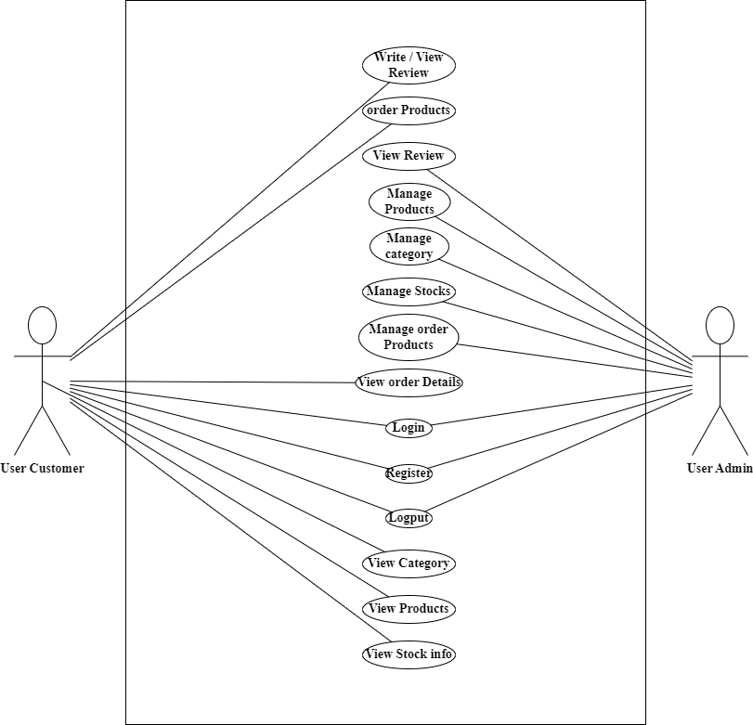

**Figure 3.1Use Case Diagram**

1. **Non-Functional Requirement:**

The system analysis of KHWOPA ECOMMERCE is done by measuring the feasibility, which are explained as followed:

* **Performance Requirement:** This system is designed for clean overall performance results. The performance of the KHWOPA ECOMMERCE will highly depend on the performance of the hardware and software components of the installed devices. Responses to view information shall take no longer than 5 seconds to appear on the screen.
* **Usability Requirement:** This system is very easy to use as it is written using basic Html, JavaScript and PHP so that the user can interact with the system easily to do the needed work. And its security feature makes it very secure and reliable.
* **Environmental Requirement:** The system shall require a localhost server, database server, and a web browser to run successfully.
* **Compatibility Requirement:** The system is compatible across all platforms under the required environment.
* **Security Requirement:** Every user shall have a unique Session while logging into the system. The user password is in encrypted format in the database

**3.1.2. Feasibility Analysis**

The feasibility analysis of KHWOPA ECOMMERCE is done by measuring the following feasibilities, which are explained as follows:

* **Technical Feasibility:** The system can be implemented in various technologies presently available and in all technologies that will be implemented in the future
* **Operational Feasibility:** The project is fully operational and exhibits satisfactory performance in terms of throughput and response times. It is capable of running efficiently on any platform, ensuring broad compatibility and effective functionality.
* **Economic Feasibility:** No economic feasibility analysis has been conducted, but it can be done based on function Point Analysis or the Kilo Line of Code method.

**Schedule Feasibility:**

Here is the Gantt chart showing the probability of the project being completed within its scheduled time limits by a planned due date.

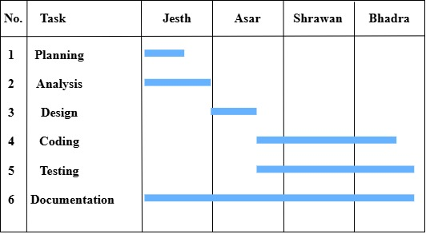

**Figure 3.2 Gantt chart**

**3.1.3. Data Modeling (ER Diagram)**

Entity-Relationship Diagram of my purposed system (KHWOPA ECOMMERCE) is sown below. Here, admin manages category, products, orders etc.

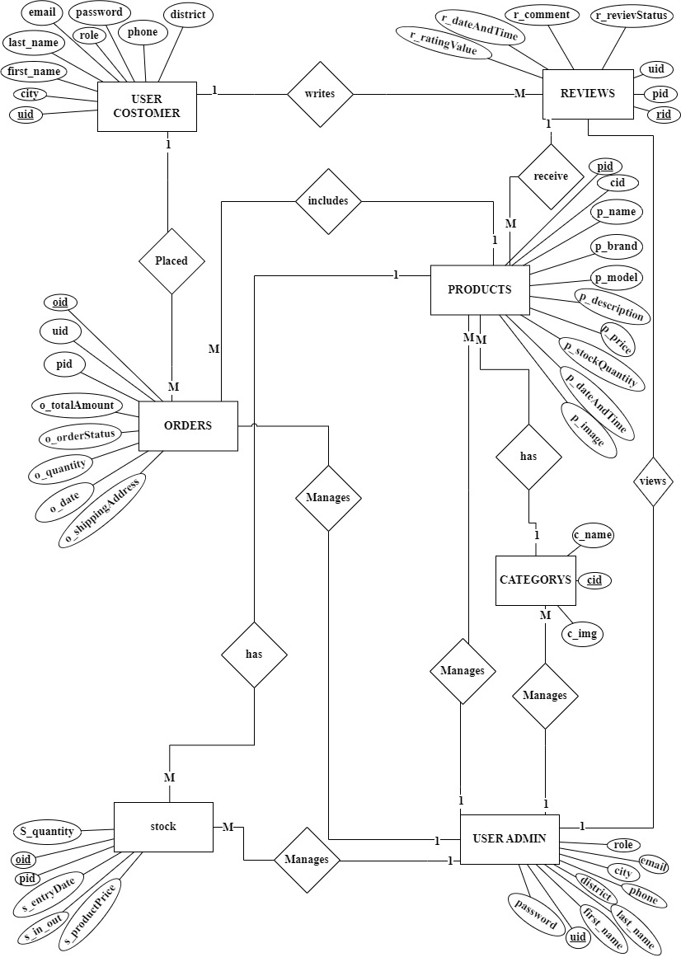

**Figure 3.3 Entity-Relationship Diagram**

**3.1.4. Process Modeling (DFD)**

For process modeling of KHWOPA ECOMMERCE, context and DFD lecel 1 are as follow:

**Context diagram**

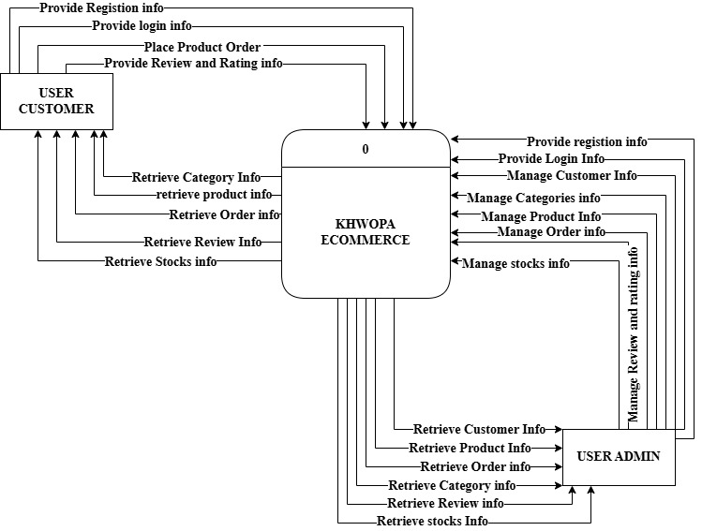

**Figure 3.4 Context level Diagram of Khwopa Ecommerce**

The figure 3.4 is also known as context level diagram. It’s a basic overview of the whole system or process being designed. The above context level diagram shows the basic overview of Khwopa Ecommerce.

**Level 1 diagram**

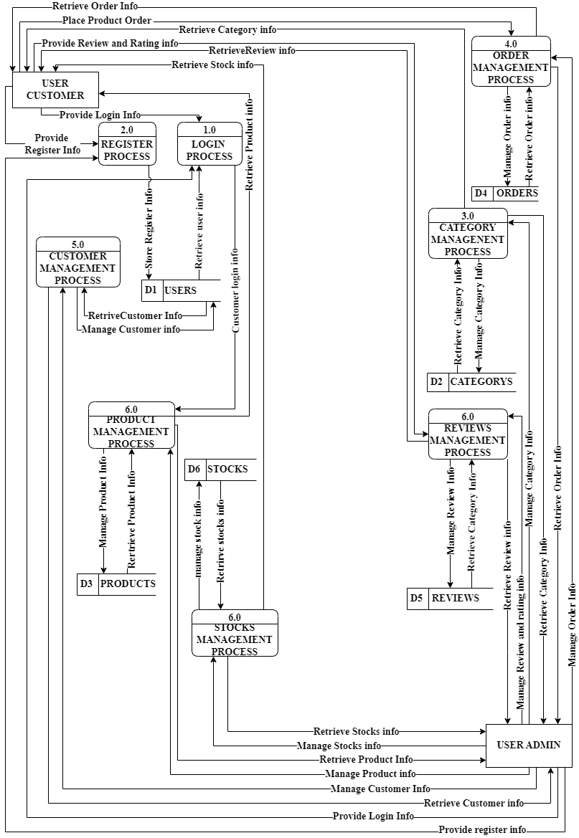

**Figure 3.5 DFD level 1 of Khwopa Ecommerce**

The above figure 3.5 provides a more detailed breakout of pieces of context level diagram. The above DFD provides the detail information of the context level diagraming of Khwopa Ecommerce.

## 3.2. System Design

The system design of Khwopa Ecommerce consists of architectural design; database schema design, user interface, and Physical DFD are shown as follows:

**3.2.1. Architectural Design**

**–**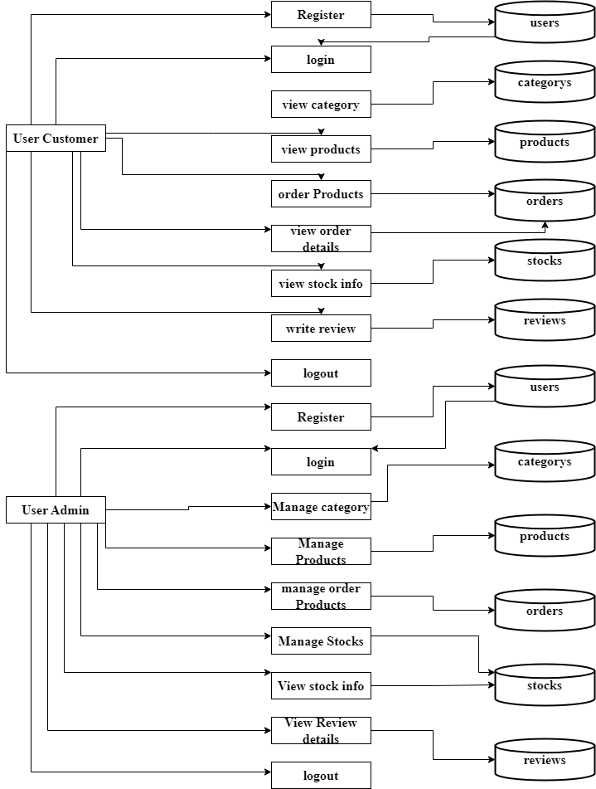

**Figure 3.6 Architectural Design of Khwopa Ecommerce**

The figure 3.6 represents the architectural design of the Khwopa Ecommerce. There are two modules into the system i.e. Admin and Customer. Customer shall register themselves into the system by filling up the necessary details and those details are saved in the user table of the data base. Admin shall login in to the system and manage category, products and order.

**3.2.2. Database Design**

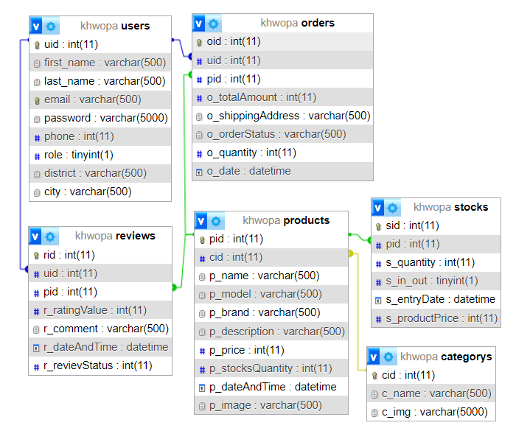

**Figure 3. 7 Database schema of Khwopa Ecommerce**

The figure 3.7 represents the database schema of the Khwopa Ecommerce showing all the relations (User Admin and Customer, products, categorys, stocks, reviews, orders) along with their respective attributes and inter-relationship between the relations.

**3.2.3. Interface Design (UI Interface)**

The interface design for all the major pages of Khwopa Ecommerce are shown as follow:

**Login Page UI**

The Login UI page of our proposed system Khwopa Ecommerce is given below. By clicking on the login button, Admin and Customers shall log into the system by providing their correct email address and their password if they have an account. If they provide incorrect email or password the system won’t let them log into the system

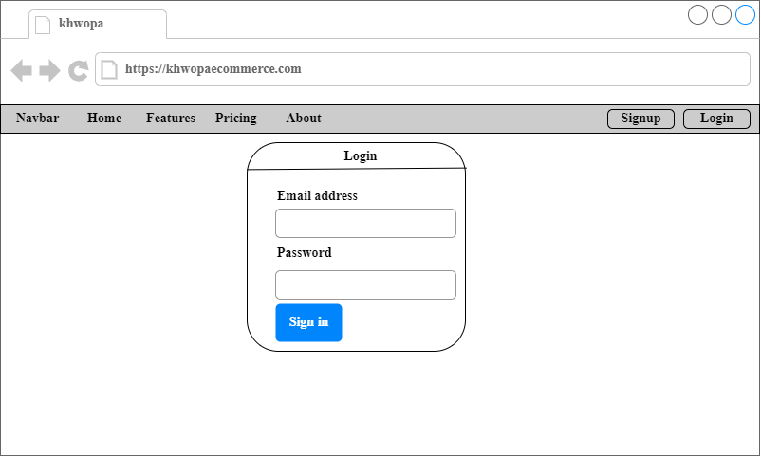

**Figure 3.8 :Login Page UI of Khwopa Ecommerce**

**Signup Page UI**

The Signup UI page of our proposed system Khwopa Ecommerce is given below. By clicking on the signup link member gets transferred to the signup page where they have to fill up all the necessary details required like full name, mobile number, email, password, District and city. By clicking on the sign-up button, member information gets stored into the database of the system. Customer have the option to login if they already have an account.

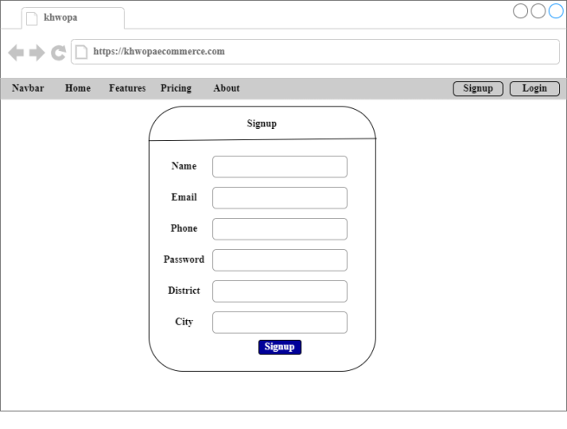

**Figure 3.9 Signup page UI of Khwopa Ecommerce**

**3.2.4. Physical DFD**

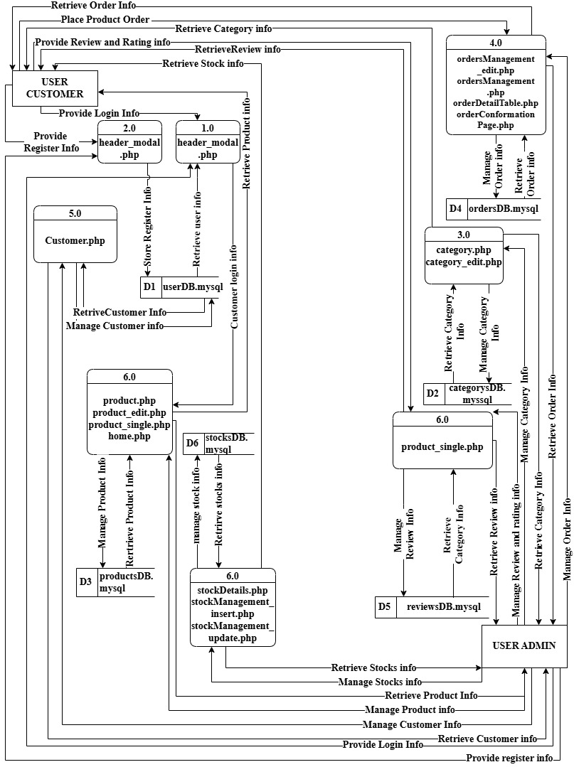

**Figure 3.10 Physical DFD**

The above figure 3.10 provides a more detailed breakout of pieces of Physical DFD. The above DFD provides the detail information and show how a system's data flows, detailing hardware, software, and manual processes involved.

## 3.3. Algorithm Used

The algorithm used in this project is Recommendation of Products According to Highest Product Rating. The recommendation algorithm in this project is based on a 5-star rating system that focuses on customer feedback for products. Customers rate products on a scale from 1 to 5, with a higher rating showing greater satisfaction. Products with the highest ratings are then recommended to other customers.

**1 Star:** Very Poor

**2 Stars:** Poor

**3 Stars:** Average

**4 Stars:** good

**5 Stars:** Excellent

To illustrate the practical application of the average calculation, let's consider an example. Imagine that 15 Customers rated the one of the product, with the following breakdown:

4 Customers gave 5 stars

5 Customers gave 4 stars

1 Customers gave 3 stars

1 Customers gave 2 stars

1 Customers gave 1 star

The total rating sum would be calculated as follows: 4×5 + 5×4 + 1×3 + 1×2+1×1 = 64

The average rating is then determined by dividing the total rating sum by the number of Customers [8]: 46/12=3.8

Then it is round of then the average ratting will be 4. This value will be used to show the stars in event pages

**Before rating**



**After Rating**



Then recommend according to high rating on the homepage.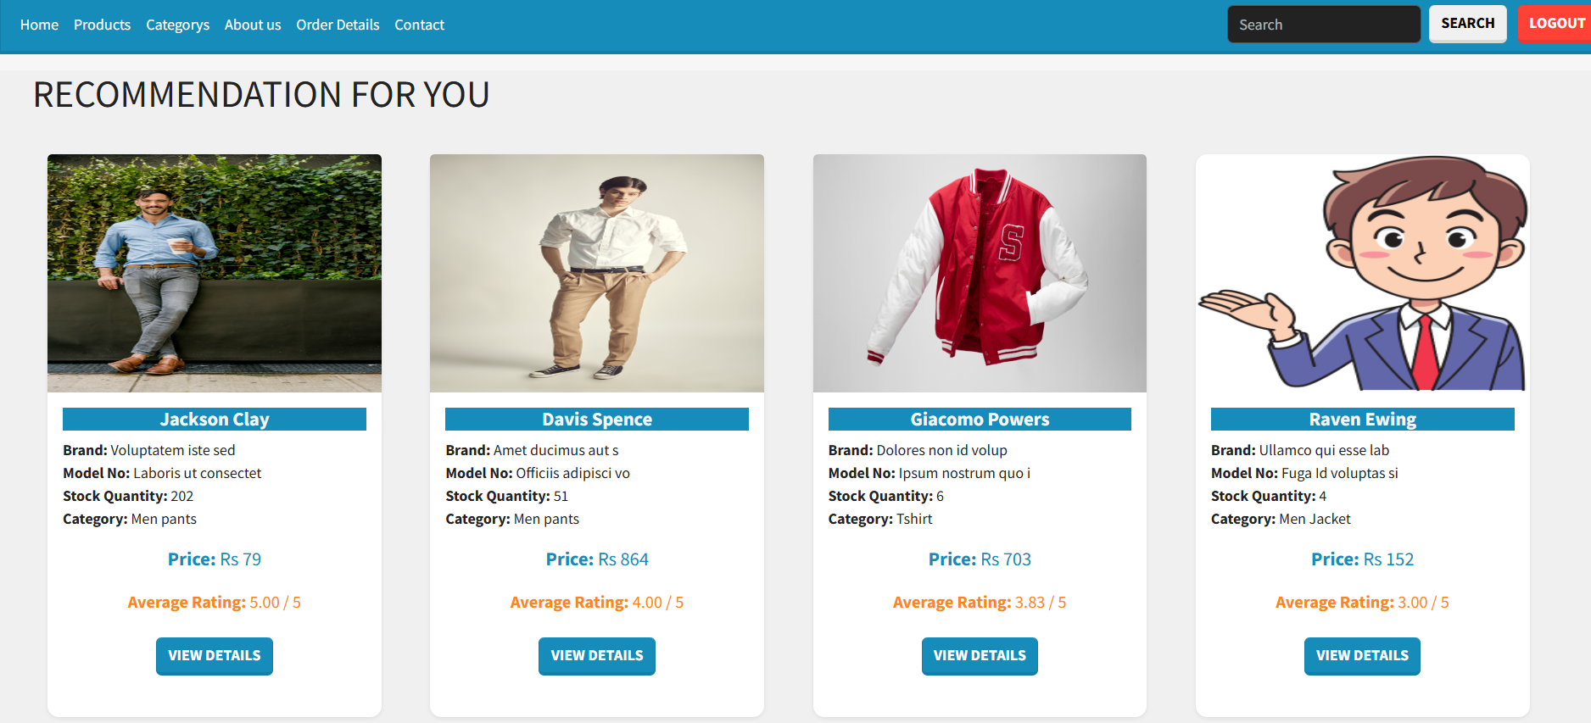

# CHAPTER 4: IMPLEMENTATION AND TESTING

## 4.1. Implementation

The tools and techniques used to implement the system and the implementation details of various modules of KHWOPA ECOMMERCE are as follows:

**4.1.1. Tool Used (CASE Tool, Programming Languages, Database platform)**

The tools used for the implementation of Gym Subscription Management are listed below:

**Draw.io**

Draw.io is an online diagram editor constructed around Google drive. Using draw.io we have been capable of creating UML diagrams, entity relations diagrams, and plenty more. One of the benefits of draw.io is that it stores the information in Google drive, consequently, there's no need for an extra third party.

**HTML CSS & JavaScript**

HTML, CSS, and JavaScript were used for the front-end development. HTML was used for the web page elements. CSS was used to provide its styling to the components. JavaScript was used for client-side validations and adding dynamic components to the Website.

**PHP**

PHP is a server-side scripting language that is embedded in HTML. It is included with some of the famous databases, which include MySQL, and its usage has helped us add, delete, and modify elements inside our database via PHP. Using PHP, we had been capable of limiting customers to get entry to a few pages of our website.

**MySQL**

MySQL is presently the most famous database management system software used for dealing with relational databases. It was used along with PHP scripts for developing our database structure. It became extensively utilized to carry out numerous activities like insertion, deletion, and update of the records saved in the database.

**Visual Studio Code**

Visual Studio Code is a lightweight but powerful source code editor which runs on computer systems and is available for Windows, macOS, and Linux.

**4.1.2. Implementation Details of Modules**

The major functions modules of KHOWPA ECOMMERCE and their implementation is shown in the figure below:

1. **Signup Module:**

This module is used to register the new user or customer into the system. Here Customer has to fill up all the necessary details about themselves to get registered. These data gathered are first validated and then stored into the database using SQL query. After the registration the registered Customer shall log into the system by providing email and password which is identical to the email and password stored into the database. The system will be designed so that the first user to register will automatically be assigned the role of Admin. For all subsequent registrations, users will be assigned the role of Customer by default. This setup ensures that only one admin account is initially created, with all other users accessing the platform as customers.

 // Check if there are existing users to determine role

    $sql = "SELECT * FROM users";

    $result = $conn->query($sql);

    if ($result->num_rows > 0) {

// For user: who registers from the second time

$stmt = $conn->prepare("INSERT INTO users (first_name, last_name, email, password, phone, role, district, city) VALUES (?, ?, ?, ?, ?, '1', ?, ?)");    }

else {

// For admin: the first person who registers first into the system

$stmt = $conn->prepare("INSERT INTO users (first_name, last_name, email, password, phone, role, district, city) VALUES (?, ?, ?, ?, ?, '0', ?, ?)");    }

$stmt->bind_param("sssssss", $fname, $lname, $email, $hashed_password, $phone, $district, $city);

1. **Rating module:**

This module is used to entry new ratings in the database. Here Customer has to fll up all necessary details about the events ratings. These data gather are first validated then stored into database using SQL query. Code where average rating algorithm is used:

<?php

    // Initialize variables for calculating the average

    $total_rating = 0;

   $rating_count = 0;

   $stmt = $conn->prepare("SELECT r_ratingValue FROM reviews

WHERE pid = ?");

                $stmt->bind_param("i", $pid);

                $stmt->execute();

                $result = $stmt->get_result();

                // Sum all the ratings and count the number of ratings

                while ($row = $result->fetch_assoc()) {

                  $total_rating += $row['r_ratingValue'];

                  $rating_count++;

                }

                // Calculate the average rating

                if ($rating_count > 0) {

                  $average_rating = $total_rating / $rating_count;

                } else {

                  $average_rating = null;

                }

                // Create the star string based on the average rating

                $star_rating = '';

                if ($average_rating !== null) {

                  // Round the average rating to the nearest whole number

                  $rounded_rating = round($average_rating);

                  echo "<p style='font-size:20px; margin:0px;'>

<strong>".$rounded_rating."</strong></p>";

                  // Generate the star string

                  for ($i = 1; $i <= 5; $i++) {

                    if ($i <= $rounded_rating) {

                      $star_rating .= '⭐'; // Full color filled star

                    } else {

                      $star_rating .= '☆'; // Empty star

                    }

}

}

else { $star_rating = '☆ ☆ ☆ ☆ ☆'; // In case there are no ratings }

echo "<div style='font-size: 38px;'>$star_rating</div>";

// Display the star rating ?>

1. **Recommendation module**

<?php

// Improved SQL query to retrieve product details along with average rating

 $sql = "SELECT products.p_name, products.p_brand, products.p_model,

           products.p_stocksQuantity, products.p_price, products.p_image,

            categorys.c_name, products.pid,

            AVG(reviews.r_ratingValue) AS avg_rating

        FROM products

        JOIN categorys ON products.cid = categorys.cid

        LEFT JOIN reviews ON products.pid = reviews.pid

        GROUP BY products.pid, products.p_name, categorys.c_name

        ORDER BY avg_rating DESC

LIMIT 4";

    $result = $conn->query($sql);

if ($result === false) {

echo "Error: " . $conn->error;

} elseif ($result->num_rows > 0) {

// Loop through each product and display its details

while ($row = $result->fetch_assoc()) {

// Display product details

}

} else { echo "No products found."; } ?>

1. **Search module**

This module is used to search the search word or term into the product name and descriptions.

 $query = "SELECT products.pid, products.cid, products.p_name, products.p_model, products.p_brand, products.p_price, products.p_stocksQuantity, products.p_image, categorys.c_name

FROM products

INNER JOIN categorys ON products.cid = categorys.cid

WHERE products.p_stocksQuantity > 0 AND (products.p_name LIKE '%$searchTerm%' OR products.p_description LIKE '%$searchTerm%')";

## 4.2. Testing

The testing section is accomplished to validate the KHWOPA ECOMMERCE. The KHWOPA ECOMMERCE is examined to test if the final system can work in keeping with what we have been waiting for and is free from any programming and logical errors. It additionally makes sure whether or not all of the systems and requirements are met or not **4.2.1. Test Cases for Unit Testing**

Unit testing is a software program development method in which the smallest testable components of an application, known as units, are individually and independently scrutinized for correct operation. Below are the numerous tables for distinctive test cases:

**Table 1: Test Case 1 Sign Up**

|  |  |  |  |  |
| --- | --- | --- | --- | --- |
| **S.N.** | **Test Case** | **Input** | **Expected Outcome** | **Outcome** |
| 1 | Navigate to sign up page | http://localhost/KhwopaEcommerce/welcomepage/home.php | sign in page should open | As expected i.e. signup modal should popup |
| 2 | Provide own details | First Name, Last Name, Email, Phone, Password, District, City | Credential can be entered | As expected |
| 3 | Click on signup button | Clicked | Customer should be signup | As expected signup succeed. |

**Table 2: Test Case 2 Sing Up Unsuccessful**

|  |  |  |  |  |
| --- | --- | --- | --- | --- |
| **S.N.** | **Test Case** | **Input** | **Expected Outcome** | **Outcome** |
| 1 | Whenever the Name field contains a number or a symbol | Eg:sum2an mushya@khwo | Display error message | An Expected Error message is displayed. |
| 2 | If the name contains more than 20 alphabets | Eg: suasdwawdaman mushyakhwo | Display error message. | As expected, Error message is displayed. |
| 3 | if the phone number is less than or more than ten numbers long and contains any alphabets | Eg: 9862123456d12 | Display error message. | An Expected Error message is displayed. |
| 4 | if an invalid email address is entered | Eg: Sumahyakhwogmai lcom | Display Error message:Output. | An Expected Error message is displayed |
| 5 | if the email address entered is already registered |  | Display error message. | An Expected Error message is displayed. |
| 6 | if the password length is less or more than 10 characters | Eg: sumaasdadsn@123 4 | Display Error message: Output. | An Expected Error message is displayed. |
| 7 | if the password and confirmation password do not match |  | Display error message. | An Expected Error message is displayed |
| Post-condition :Sign Up Failed | | | | |

**Table 3: Test Case 3 Login**

|  |  |  |  |  |
| --- | --- | --- | --- | --- |
| Pre-conditions: The member has a valid email and password. | | | | |
| Dependencies: sign-up module | | | | |
| **S.N.** | **Test Case** | **Input** | **Expected Outcome** | **Outcome** |
| 1 | Navigate to login page | http://localhost/KhwopaEcommerce/welcomepage/home.php | sign in page should open | As expected i.e. signup modal should popup |
| 2 | Correct email and password | User must login successfully | User logged into the system | As Expected i.e. User was able to access the services provided by the system |
| 3 | Incorrect email but correct password | User must not login | User was not logged into the system | User was not able to access the services provided by the system |
| 4 | Correct email but incorrect password | User must not login | User was not logged into the system | User was not able to access the services provided by the system |
| Post-conditions: Customers is validated with database and successfully login into KHWOPA ECOMMERCE  The account session details are logged into the database. | | | | |

**Table 4: Test Case 4 Add Products**

|  |  |  |  |  |
| --- | --- | --- | --- | --- |
| Pre-conditions: Admin is login into KHWOPA ECOMMERCE | | | | |
| Dependencies: login module | | | | |
| **S.N.** | **Test Case** | **Input** | **Expected Outcome** | **Output** |
| 1 | Navigate o Product page | http://localhost/KhwopaEcommerce/admin/product.php | Product page should be open | As expected i.e. admin is navigated to category page of system |
| 2 | Click on add product Button | Button Click | Add product Form page should be open | As expected i.e. admin is navigated to add Product page of system |
| 3 | Provide all required information | Product Name, Category, Model no, Brand, Description, Pice, Upload Image | Credential can be entered | As expected if all textboxes are filled and image validation is successful then it is accepted otherwise we will show an error. Error message. |
| 4 | Data insertion | Click on the add category | Admin should be able to add a Products into the system | As Expected i.e. Admin can add Products the system |
| **Post – conditions**  **The Product is successfully inserted into the database.** | | | | |

**4.2.2. Test Case for System Testing**

System Testing is a form of software testing that is executed on a complete integrated system to assess the compliance of the system with the corresponding requirements.

**Table 5: Test Case 5 System Test**

|  |  |  |  |  |
| --- | --- | --- | --- | --- |
| **Pre – conditions: Admin is login into the Khwopa Ecommerce** | | | | |
| **S.N.** | **Test case** | **Input** | **Expected Outcome** | **Output** |
| 1 | Check with admin login | Email:admin@gmail.com  Passwoed:suman@1234 | Successful Login | Open Dashboard |
| 2 | Check with delete and edit category | Click and delete and edit button | Must be edited or deleted | Edit and delete messages should be displayed successfully. |
| 3 | Check with delete and edit Products | Click and delete and edit button | Must be edited or deleted | Edit and delete messages should be displayed successfully. |
| 4 | Check with order status Pending, conformed, completed | Click and update Button | Must be edited pending or conformed or completed | Edit message should be displayed successfully. |
| 5 | check with logout | Click logout button | Successfully logout | Redirect to home page |

# CHAPTER 5: CONCLUSION AND FUTURE RECOMMENDATIONS

## 5.1. Lesson Learnt

With the growth and development of the project, we also grew our knowledge little by little. We have learned lots of problem-solving skills and learnt things like teamwork, finding the solution on our own, proper use of guidelines, communication and writing skills and management of the team. This project didn’t only help in our academic development but also widened our horizon of curiosity. We have found ourselves more eager to learn about new languages and designing techniques while developing this project.

## 5.2. Conclusion

While working on this project, I have learned many valuable things that are being implemented on real-world projects. Through the research done to start this project I learned the various types of travel system being implemented around us. Although this project was supposed to be an academic fulfillment, with the help and guidance of our teachers and seniors I learned many more about software management, project planning, testing, database management, rules to be followed while creating a project or software, time management, and most importantly to be patient.

Although the project has turned out be exactly what I had expected it to be**,** there are many more functions that can be added to the system and improved making the system even more feasible and operational

## 5.3. Future Recommendations

The possible improvements that can be made for this system are:

* Recommendation of products using AI.
* Adding coupon system.

# REFERENCES

# Bibliography

|  |  |
| --- | --- |
| [1] | R. Lixandroiu, "AN ANALYSIS ON CHOOSING A PROPER ECOMMERCE PLATFORM," vol. 16, 2015. |
| [2] | R. Varadarajan, "Marketing Strategy in an Internet-Enabled Environment," vol. 23, no. 1, 2008. |
| [3] | X. T. Kong, "Cyber physical ecommerce logistics system," 2020. [Online]. Available: https://www.sciencedirect.com/science/article/abs/pii/S0360835219306394?via%3Dihub. |
| [4] | A. Ghandour, "ECOMMERCE WEBSITE VALUE MODEL," 3 04 2015. |
| [5] | R.R.K.Sharma, "Factors Affecting Consumers’ purchasing Decision," 8 10 2016. |

# APPENDICES

**Home page**

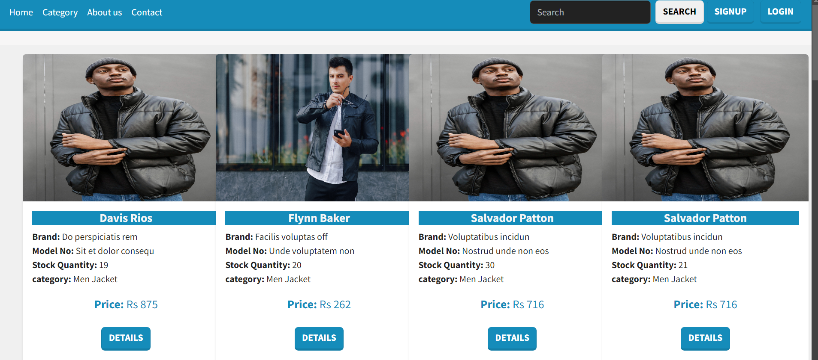

**Category page**

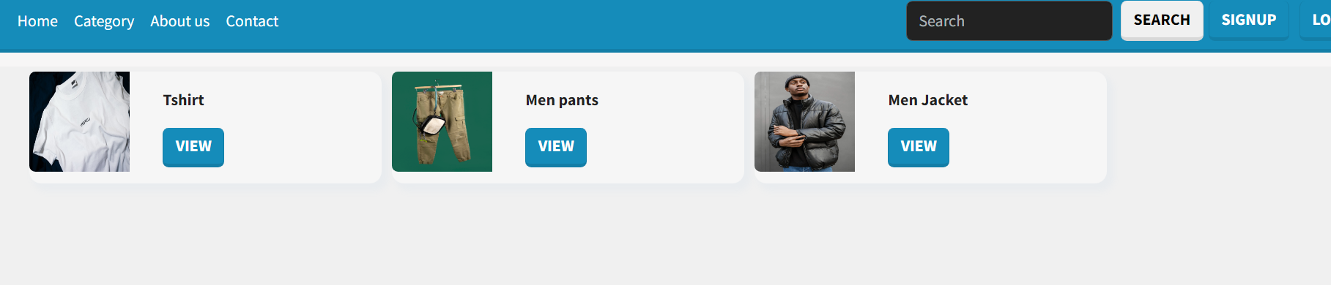

**Admin product page**

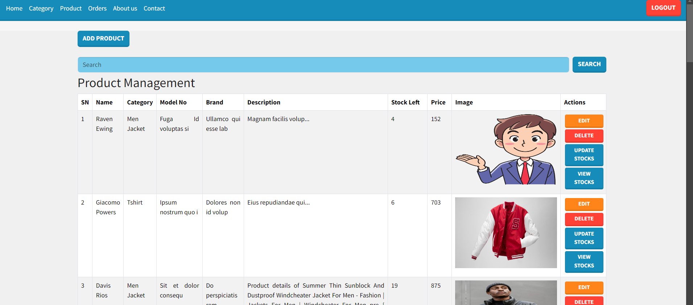

**Admin Order Detail Page**

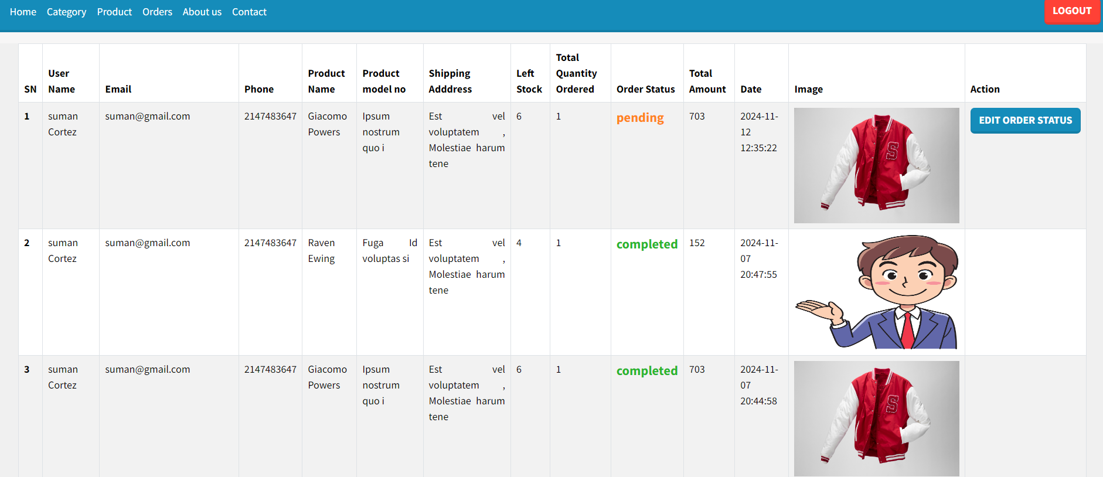

**Customer product page**

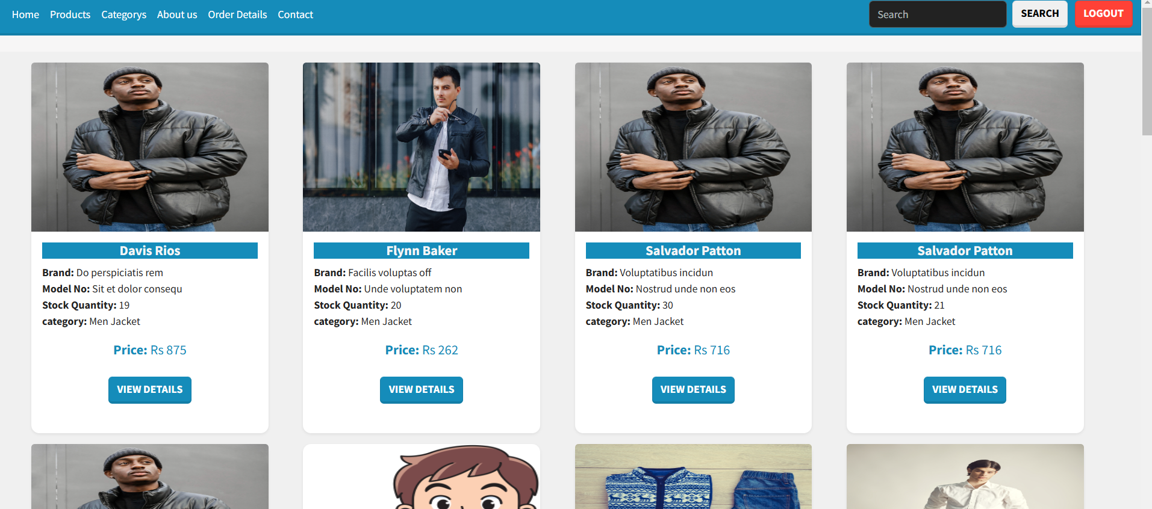

**Customer Order Detail Page**

